Paper Title
Technical Track Number and Technical Track Name
Note: Do not include author names or affiliation anywhere in the digest – the review process is double blind

ABSTRACT
This document is a template for a conference digest or paper proposal. The digest should clearly state the objectives of the proposed paper, outlining the problem requiring solution or the method of approach to research, be explicit with respect to the type of data and analysis to be included in the full paper, and summarize the conclusions being made. The digest must also include references to relevant technical papers and the body must not exceed five pages in length. The references may extend onto a sixth page.

INTRODUCTION
Each digest must include the paper title and the technical track number and technical track name. The review process is double blind, so the authors must not include their names or affiliation anywhere in the digest. The digest should include an abstract of up to 200 words and a total length of 3-5 pages including figures and tables, with references extending onto a sixth page if needed. The digest should be formatted with a single-column, 10 to 12 point font, and double spacing as shown in this example digest. The body of the digest should include an introduction with references, a body which describes the research for the proposed paper in detail, and a conclusion and future work section which describes the conclusions of the work and any additional material, such as further analysis or experimental results, which will be provided in the final paper.

BODY SECTION I

Body Subsection
The body of the paper can include figures, for example Fig. 1, as well as tables such as Table 1 below.
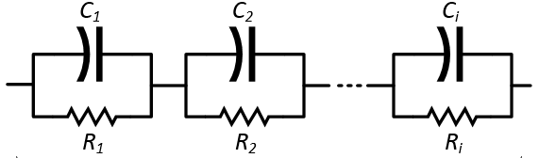 | Table 1: Example Circuit Parameters  Parameter Symbol Value  Capacitance C₁ 0.1 F  Resistance R₁ 10 Ω  Capacitance C₂ 0.1 F  Resistance R₂ 10 Ω
Fig. 1 Example circuit

BODY SECTION II

CONCLUSIONS and FUTURE WORK
The digest should end with a conclusion and description of future work which will be included in the final paper.

REFERENCES
[1] A.J. Author, "Brief fundamentals of digest preparation," Trans. Conference Preparation, vol. 1, pp. 1-2, Oct. 2018.

